|  |
| --- |
| DROP-DOWN PREDEFINED LISTS |

You’ve finished making initial configuration to the database fields but there are still several fields that need attention particularly because they all should be rendered as dropdown menus or radio buttons (with the exception of the foreign-key relationships, which will be taken up much later). While they can be configured in the same manner as that of a regular field, they require an additional configuration step to work properly – configuring their “Predefined Lists”.

**ADDING A PREDEFINED LIST**

Back on the Cobalt Control Center, select the “Predefined Lists” option.

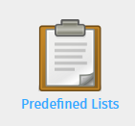

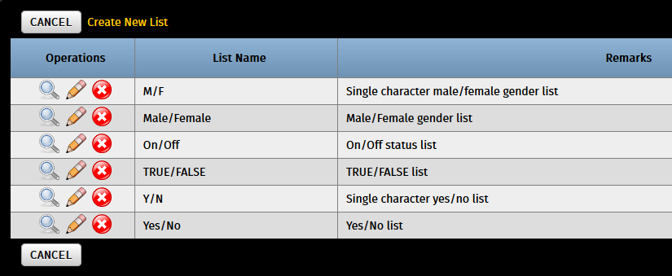

You will notice that it has already been prepopulated with usually-used lists such as gender selection and generic Boolean true/false, yes/no choices. For this, we will create a new predefined list that satisfies a dropdown condition for our **class** table’s class_type field. It should be a dropdown list that displays three options: *Melee, Ranged,* or *Magic*.

Hit “Create New List” and fill out the required fields. Since we need 3 dropdown items, put “3” on the “Change # of items to” field then hit “Go” to update the form and display 3 list items for us to put our options in.

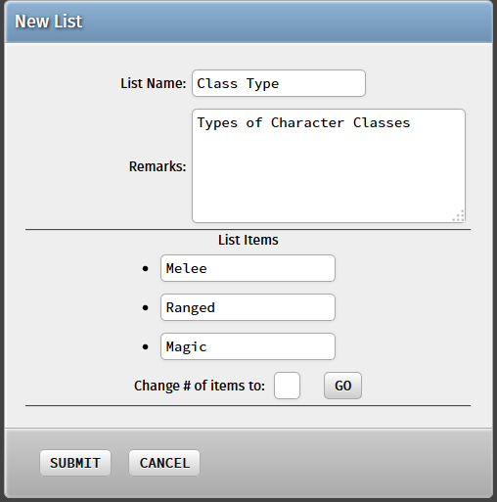

Hit “Submit” and our new predefined list should be available for use!

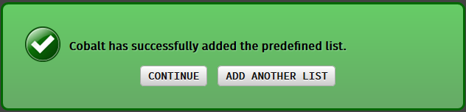

**CREATING A DROPDOWN LIST WITH THE PREDEFINED LIST**

Return to the “Fields” option and configure the class_type field of the class table:



Change the Control Type to “Drop-down List” or “Radio Buttons”, whichever you prefer:

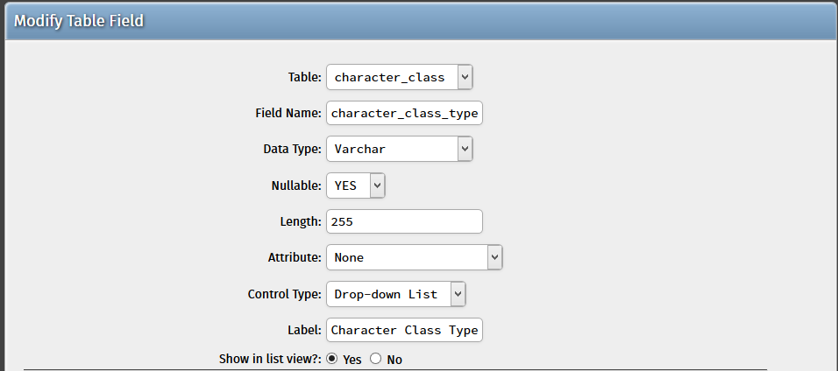

In addition, navigate down to the “Additional Options”, where there are additional guide conditions mainly for Drop-down Lists and Radio Buttons. Since we selected “Drop-down List” above, we need to answer Option #2, wherein we’ll indicate that we’re using a Predefined List.

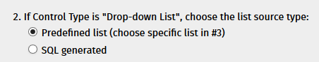

We need to choose a specific list in #3 afterwards (you may skip over to this part if you selected “Radio Buttons” on the Control Type above). Select our newly-created “Class Type” Predefined List.

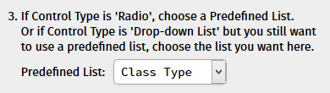

Hit “Submit” and then go through the process of re-generating and updating your project once again. This time only generate the “class” subclass as this is the only table that we have modified.

Navigate to your project’s “Character Class” module and hit “Add new record”. The field has successfully been transformed into a drop-down list with our predefined field!

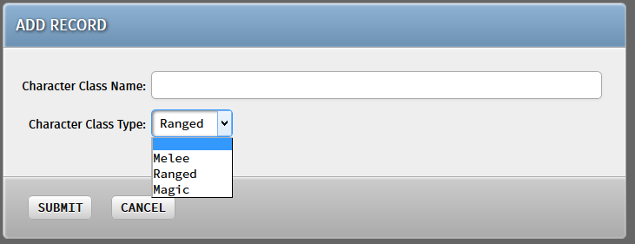

**TRY IT YOURSELF!**

While considerably easier, the gender field in the character table also needs to be transformed into a drop-down list or radio button. It already has a predefined list on the code generator so it is simply a matter of transforming the field into a drop-down / radio button.